Snacks/Recess.
Plain popcorn.................... Small 50c
............... Large $1.00
Garlic Bread …………………. 30c
Or $2 per roll (8 pieces)
Hash Brown ……………. $1.00
BBQ Chicken Turkish............... 80c
Cheese & bacon Turkish ....... 80c
Cheese Turkish ………………… 70c
Mini Yoghurt Cup ................ 30c
Mini Juice Cup .................. 30c
Frozen Fruit Pops …………... 50c
Choc Brownie Slice …………. 70c

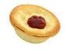

Hot Food.
Lean Sausage Roll ............ $2.20
Lean Beef Pie ................... $3.30
Mini Lean Beef Pie……… . $1.70
Chicken Nuggets ............. 60c
GLUTEN FREE Chicken Nuggets…. 60c
Chicken & Salad Wrap.............. $4.00
Corn on the Cob…………. $1.20
Hash Brown ………………. $1.00

ST CECILIA’S CANTEEN MENU, TERM 1 2019.

Sandwiches.
Vegemite & Cheese ……………… $2.50
Cheese .................................. $2.00
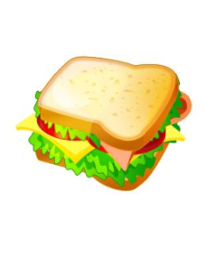
Cheese & Tomato ................ $2.50
Ham, Cheese & Tomato ....... $3.00
Ham & Cheese........................ $2.50
Ham & Salad ……………………… $3.50
Chicken & Salad …………………. $3.50

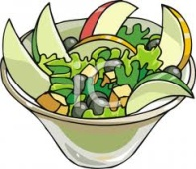

Salads.
Lettuce, tomato, cucumber, beetroot, grated carrot, low fat dressing.
Small Tub ........................... $2.50
Large Tub ......................... $3.50
Warm Chicken Salad……… $4.50

*Add a side salad to a hot meal and
‘Green it up’!!

TOMATO OR BBQ SAUCE 40c
**All sandwiches served with one slice white & one slice of wholemeal bread
**Lunch bags are available for 20c each

Drinks.
300ml Plain Milk ................... $1.50
300ml Flavoured Milk .......... $2.00
(Chocolate, strawberry)
200ml OJ .............................. $2.50
200ml AJ .............................. $2.50
200ml Apple Blackcurrant.... $2.50
250ml Lemonade Sports Water...$2.00
250ml Raspberry Sports Water… $2.00
350ml Plain Water................ $1.00
Sipahh Straw………………… 80c

Icy Treats
Zings…………………………… 70c
Plain LF Ice Cream Cup……. $1.20
Lemonade Icy Twist ………. $1.50
Add Milo to Ice Cream Cup 30c

**Canteen is open Wednesday & Friday.

** Extra Plastic Fork or Spoon 10c each
**Order online with Qkr!

