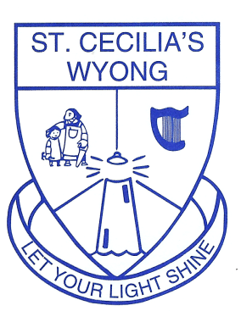
St Cecilia’s Catholic School
Panonia Road, Wyong 2259
Telephone: (02) 4353 2922
Email: scw@dbb.catholic.edu.au
Web: www.scwdbb.catholic .edu.au

Dear Parents and Carers,
We are very excited about your child joining St Cecilia’s Primary School. Their first day of school will be Thursday 3rd February 2022.
All Kindergarten children will come to school for one hour for a Mathematical Assessment Interview and Best Start Assessment on either Monday 31st January, Tuesday 1st February or Wednesday 2nd February.

For Kindergarten students, school starts at 8.45am and finishes at 3.00pm in Term 1. On their first day of school children are to be in their full school uniform. They will be greeted at the bottom of the Kindergarten ramp by a year 6 student and taken to their classroom. Following this, parents are welcome for a cup of tea in the hall, Covid permitting.

Families will need to purchase the following items for their first day of school:

- Library bag (labelled)
- Painting shirt (labelled)
- Wet wipes
- Packet of 12 Twist up crayons (labelled)
- 3 HB lead pencils (triangular grip if possible and labelled)
- Pencil Case (labelled)
- Small children’s safety scissors (labelled)
- 3 Glue sticks (preferably Bostik and labelled)
- Spare underwear and socks (to be kept in school bag)
- 2022 Diary (example below)
- Clear document wallet (example below-labelled)
- Headphones (labelled)
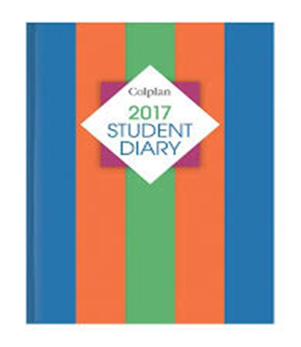
- Lunch box and drink bottle (easily opened and closed by your child-labelled)

Five scrapbooks will be sent home at the start of term for covering. Please cover in clear contact as they will have a cover sheet already attached.
The St Cecilia’s community looks forward to welcoming your family from the 31st January.

Mrs Milne and Mrs Cattabriga

YEAR 1 CLASS REQUIREMENTS – 2022

These items will be stored and shared among the class throughout the year:  8 glue sticks (UHU or Bostik brand recommended)  12 lead pencils HB  1 large box tissues  1 large packet of wet wipes | For your Individual child  Please ensure all items are clearly labelled with your name  Coloured pencils  Twistable crayons  Textas  1 eraser  1 pair scissors  6-8 whiteboard markers  1 pencil sharpener (no electric sharpeners)  Pencil Case: no pencil tins or equipment for their desk please  2 x Plastic document wallets  1 library bag  1 inexpensive pair of headphones to use with iPads.  1 student diary (see picture below for required layout)  30cm ruler (plastic or wooden)  Paint Shirts, if still in good condition from previous class will be sent to their new classroom

1 Dictionary (Macquarie or Oxford early primary dictionary recommended – see picture)
1 Thesaurus (Macquarie or Oxford early primary thesaurus are recommended. - see picture)
(Please ensure that the text is not too small for them to read.)
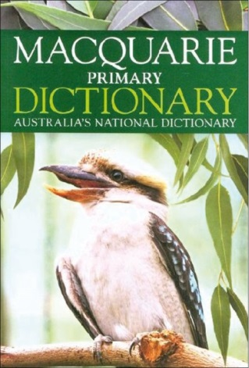
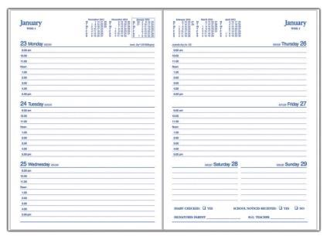

Dictionary/Thesaurus Recommendation Diary Recommendation

We look forward to seeing you in 2022
Have a wonderful Christmas
These items will be stored and shared among the class throughout the year:  4 glue sticks (UHU or Bostik brand recommended)  12 lead pencils HB  1 large box tissues  1 large packet of wet wipes | For your Individual child  Please ensure all items are clearly labelled with your name  Coloured pencils  Twistable crayons  Textas  1 eraser  1 pair scissors  4 whiteboard markers  1 pencil sharpener (no electric sharpeners)  Pencil Case: no pencil tins or equipment for their desk please  2 x Plastic document wallets  1 library bag  1 inexpensive pair of headphones to use with iPads.  1 student diary (see picture below for required layout)  1 Paint shirt
YEAR 2 CLASS REQUIREMENTS – 2022

Dictionaries and Thesaurus will be sent to new classrooms

Diary Recommendation

We look forward to seeing you in 2022
Have a wonderful Christmas

YEARS 3 AND 4 CLASS REQUIREMENTS - 2022
(Please ensure all items are clearly labelled with your name)
- 1 library bag
- 1 painting shirt
- 6 lead pencils HB
- 1 pencil sharpener
- 2 erasers
- 6 pack highlighters
- 4 red pens
- 4 blue pens
- 1 green pen
- 2 felt tip black pens
- 2 Artline 0.6mm felt tip black pens
- Coloured pencils, crayons and/or textas
- 4 glue sticks per term
- 1 pair scissors
- 30cm ruler
- 6 whiteboard markers
- 1 whiteboard eraser
- 2 packets of page tabs
- 1 basic calculator
- Small pair of headphones
- 2 A4 plastic document wallets
- Ziplock bags
- 1 packet of wet wipes
- 1 box tissues or paper towel
If your child does not already have a dictionary and thesaurus at school, please supply them for the new year.

We look forward to seeing you in 2022
Have a wonderful Christmas

2022 Years 5 and 6 Class Requirements

(Please ensure all items are clearly labelled with your child’s name)
- 1 library bag
- 3 lead pencils HB
- Coloured pencils
- 1 eraser
- 2 boxes of tissues
- 2 packets of wipes
- Headphones (inexpensive)
- 1 pencil sharpener
- Textas
- 4 glue sticks
- 1 calculator
- 30cm ruler
- 4 blue pens
- 4 red pens
- Scissors
- 2 highlighters
- Compass set
- 4 whiteboard markers
- Roll on deodorant (to be kept in their school bag)

We look forward to seeing you in 2022
Have a wonderful Christmas

