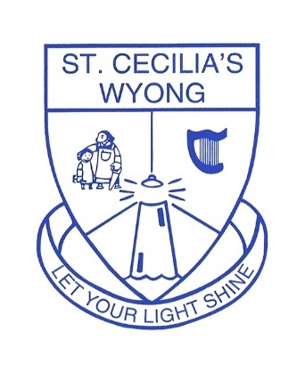
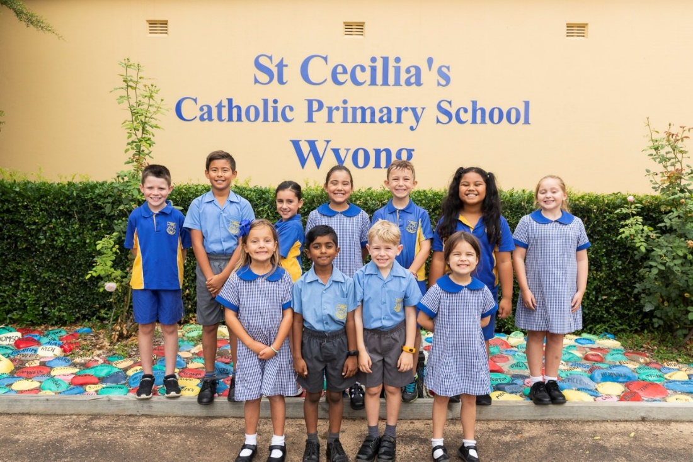
St Cecilia’s Catholic Primary School, Wyong
15 Panonia Road, Wyong NSW 2259
02 43532922 | www.scwdbb.catholic.edu.au

Parent Information Book

2022

2022

St Cecilia’s
Catholic Primary School
Wyong

Welcome Message from the Principal

Dear Parents,
Welcome to our school community. You have chosen a school whose fundamental belief is that God loves us, and we are called upon to respond to God in love, thanks and praise. Your choice to enrol your child in St Cecilia's Catholic School means that you have openly, and at personal cost, affirmed your belief in the basic values of a Catholic education.

Whilst caring for the spiritual growth of our children, we are also concerned with their academic, physical, emotional and social development. We believe it is essential that all children be supported to attain the highest level of which they are capable, in all areas. Most importantly, we believe that each child is a unique individual. As their teachers, we love and care for them by striving to develop within them a sense of positive self-worth.

We invite you to take an interest and active part in your child's education and attend functions, both educational and social, that are arranged by the school and Pastoral Care Team. Your child will then have the benefit of seeing that you are actively involved in their education. Newsletters, Parent/Teacher interviews and meetings and other parent gatherings are important avenues of communication between the school and family.

We wish you and your family a very long and happy association with St. Cecilia's.

Yours sincerely

Mrs Marta Chylewska
Principal

Contents
Welcome Message from the Principal 1
Brief History of St Cecilia’s Catholic School 4
St Cecilia’s Vision and Mission Statement 5
Vision Statement 5
Mission Statement 5
General School Information 6
School Contact Details 6
Parish Information 6
St Cecilia’s Staff 6
Teaching and Learning 8
Curriculum 8
Homework 9
Reports and External Assessments 9
Technology 9
CATHOLIC MISSION 10
Liturgical Celebrations 10
Sacramental Programs 10
Social Justice 10
WELLBEING FOR LEARNING 11
Acknowledging Positive Behaviour & Awards 11
Safeguarding 11
School Rules and Behaviour Expectations 12
Student Leadership Opportunities 12
Support for Students & Families 13
COMMUNICATION 15
Appointments 15
Communication Channels 15
Contact Details 16
SCHOOL ORGANISATION 17
Allergies 17
Asthma and Anaphylaxis 17
Attendance and Absences 17
Excursions or Incursions 18
Fees 18
Immunisation 19
Library 19
Lost Property 19
Local Excursions 19
Medical Matters 19
Mobile Phone and Wearable Devices 20
Payments 20
Photo/Video Permission 20
Policies 21
Raising Concerns 21
School Photos 21
Sport 21
Sport Colour Houses 21
Staff Development Days 22
Supervision 22
Travel 22
Uniform 24
Valuables 26
Visitors 26
PARENT PARTICIPATION 27
Families Leading in Partnership (FLIP) 27
Parent Helpers/Volunteers 28
APPENDIX 30
Appendix A – Working With Children Check 30
Appendix B - Safeguarding 30
Appendix 3 – Maintaining Professionalism 31

Brief History of St Cecilia’s Catholic School
In 1916, the Sisters of St Joseph came to Wyong to establish a convent and school. The convent was originally one of the stately homes of Wyong, and was built about 1907 for a Mr. Samuel Whittle.
The Sisters of St Joseph, who established it as both a day and boarding school, acquired it. The school was named St. Cecilia's, in honour of Miss Cecilia Woodbury, who raised most of the funds to erect the parish church. The convent provided secondary education up to Intermediate certificate level. The sisters were also highly regarded for their ability to teach music.
After many years, the boarding section of the convent was dispensed with, and St Cecilia's became a day school only. The Sisters of St. Joseph continued in residence there until the end of 1978, when they moved to the convent at The Entrance, due to the serious deterioration of the Wyong premises. The parish purchased the site and in October 1981, the old convent was demolished.
During the early eighties, there was a considerable increase in school enrolments and classroom blocks were erected to cater for the numbers.
Today, St Cecilia's is a co-educational school of 300 students from Kindergarten to Year 6. When our students leave St Cecilia's at the end of Year 6, most continue their education at the regional co-education Catholic High School, St Peters College, Tuggerah Lakes and to a lesser extent MacKillop Catholic College, Warnervale.
The Sisters of St Joseph withdrew from St Cecilia's at the end of 1988 and a lay-principal was appointed in 1989. The school community will always remember with love and gratitude the Sisters, who gave so much to the children and families of the Wyong Parish.
2016 marked 100 years of Catholic education at St Cecilia’s and we are proud of the school and its achievements.

St Cecilia’s Vision and Mission Statement
Our Vision and Mission Statement is the core of our role as a Catholic School.

Vision Statement
St Cecilia’s Catholic Primary School is a place of learning, where students thrive in a safe and nurturing environment. United in our faith, students build strong relationships that foster trust, compassion and respect.

Mission Statement
As a school community, we are committed to:
Strengthening and deepening student faith development and discipleship. Educating them in the knowledge and traditions of the Catholic Faith.
Providing a nurturing, welcoming, caring and inclusive community that caters for and values the needs of each student.
Developing students’ skills and confidence to challenge themselves, to examine and question, explore connections and make decisions.
Developing students’ ability to think creatively, be confident problem solvers and risk takers with a growth mindset.
Engaging students in authentic, collaborative and purposeful learning experiences, fostering a lifelong love of learning.
Supporting the wellbeing of each student, helping them to be resilient and develop positive relationships.
Empowering students to contribute positively to the school and wider community.
“Let your light shine”

General School Information

School Contact Details

SCHOOL ADDRESS | 9 – 13 Panonia Rd Wyong
SCHOOL TELEPHONE | 4353 2922
EMAIL | scw@dbb.catholic.edu.au
SCHOOL WEBSITE | https://www.scwdbb.catholic.edu.au/
SCHOOL HOURS | 8:45am – 3:05pm  A teacher is on duty to supervise the children from 8.15am
OFFICE HOURS | 8.30am – 4:00pm

Parish Information

PARISH PRIESTS | Fr Father Raul Balute (Parish Priest)
 | Fr Alex Barnedo (Assistant Priest)
PARISH TELEPHONE | (02) 4352 1011
PARISH WEBSITE | Wyong - Catholic Diocese of Broken Bay (bbcatholic.org.au)

St Cecilia’s Staff
Principal | Mrs Marta Chylewska
Assistant Principal/ Collaborative Coach | Mr Paul Madigan
Religious Education Coordinator | Mrs Jamie Dowling
Wellbeing for Learning Leader | Lianna Jones
Literacy Coach | Emily Adcock
Numeracy Coach | Victoria Jones
Family Liaison Officer | Natasha Harman (Tuesday & Thursday)
Aboriginal Education Worker | Jodie Bourke
School Counsellor | Wendy Thomas
Administration Officers | Mrs Donna Clancy (Mon-Thur)  Cheryl O’Neill (Mon-Wed)  Ranee Bagiossi (Fri)

Classroom Teachers
Kindergarten Blue | Mrs Anastasia Cattabriga
Kindergarten Gold | Mrs Annette Milne
Year 1 Blue | Miss Sarah McEwan
Year 1 Gold | Mrs Victoria Jones (Mon – Wed)  Emma Herd (Th & Fri.)
Year 2 Blue | Mrs Jaclyn Sheppeard
Year 2 Gold | Mrs Mikaela Scott (Mon. – Wed.)  Tenille Callaghan (Th. & Fri.)
Year 3 Blue | Mrs Emily Adcock (Mon. - Wed.)  Ms Carol Nash (Thur. & Fri.)
Year 3 Gold | Mr Patrick Murton
Year 4 Blue | Mrs Chloe Harrison (Mon., Wed. – Fri.)  Mrs Tenille Callaghan (Tue,)
Year 4 Gold | Mrs Sylvanna Jordan
Year 5 Blue | Mrs Sarah Xuereb
Year 5 Gold | Mrs Jamie Dowling (Mon. - Thurs) Mr Paul Madigan (Fri)
Year 6 | Miss Molly Clancy
Teacher Librarian | Mrs Virginia Cumming (Tues. – Thu. & Every second Mon.)
Creative Arts | Mrs Jannette Whyte (Tues. & Wed.)
Japanese | Mrs Tony Brinley (Tues. & Wed.)
Learning Support Teacher | Mrs Lianna Jones
Learning Support Assistants | Rosa Sweeney, Michele Hopwood, Angela Sartor

Teaching and Learning
At St Cecilia’s we deliver a rich and engaging curriculum where thinking is valued, visible and actively promoted through the lens of Visible Thinking and an Inquiry-based approach to teaching and learning. Thinking strategies and an inquiry methodology is integrated across all subject areas. This helps our children to think critically, creatively, explore deeply, challenge themselves, contribute positively to their world and learn from their failures and successes.
A growth mindset is nurtured in all children to assist them to continue working hard, even when they are met with obstacles or failures. This in turn, sees the children persevere, adapt, and try different strategies they’ve learned. By instilling this mindset in the children, we believe we are equipping them the skills and outlook which will support their learning throughout education and into adult life.
The use of technology within the classrooms is prominent throughout the school. St Cecilia’s has embraced the concept of flexible learning spaces in our classrooms from Years 3 to 6. Each classroom has an Interactive Whiteboard and is air-conditioned to ensure that students can learn in comfort.

Curriculum
The Religious Education program has been developed by Catholic Schools Broken Bay. Daily classroom prayer and attendance at Mass are a regular part of the school programme. Religion is taught for approximately half an hour a day.

The English curriculum involves the integration of the children's listening, speaking, reading, and writing. Through modelled, guided, shared and independent learning experiences children develop the ability, confidence, and interest in both spoken and written language. English is taught for approximately 6-8 hours a week.

The Mathematics curriculum consists of 3 strands – Number and Algebra, Measurement and Geometry, Statistics and Probability. It aims to develop concepts and operational skills through the regular use of structured materials, which will enable the children to discover relationships and apply these to real life situations. Approximately 5 hours per week.

Human Society and Its Environment (HSIE) curriculum consists of History and Geography and is concerned with the study of people, their history, varying cultures, and environments. Particular attention is focused on our own country with its multicultural society. Approximately 1.5 – 2 hours per week.

Science and Technology curriculum provides children with opportunities to learn about the natural and made environment, with emphasis on firsthand experiences, inquiry and problem solving. Approximately 1.5 - 2 hours per week.

Creative And Performing Arts curriculum includes music, drama, visual arts and dance and provides children with a wide variety of opportunities for creativity and self-expression. Approximately 1.5-2 hours per week.

Personal Development, Health, and Physical Education (PDHPE) curriculum includes 3 content strands: Health, Wellbeing and Relationships, Movement Skill and Performance, Healthy, Safe and Active Lifestyles. Approximately 1.5 – 2 hours per week.

Homework
Regular homework is a valuable component of the learning experiences provided in a child's primary education. An effective homework program will provide the children with the opportunities to develop and revise and consolidate concepts taught in class. It also provides parents with the opportunity to become more actively involved in the education of their child and offers them some insights into their academic progress and what they are learning about in class.

Reports and External Assessments
Reporting to parents/carers occurs at the end of Semester 1 and 2 using a written report and the A–E grading scale or equivalent. The scale provides a common language for reporting.
Assessments are completed in classrooms during the year and some standardised testing takes place across the school. The NAPLAN (National Assessment Program – Literary and Numeracy) Tests are administered in Years 3 and 5 in May.
If your child attends an outside agency for assessment, eg. ears, eyes, psychometric testing, it is important that a copy of the report be forwarded to the school via the office, who will send it on to the class teacher, Principal and the Learning Support team.

Technology
At St Cecilia’s we have 1:1 Chromebooks in Years 5 & 6, 1:1 iPad’s in Years 2, 3 & 4 and approximately 20 devices in each Kinder and Year 1 classrooms. These are school owned and managed devices. We believe we are preparing our students for now and the future through using these learning tools. All classrooms have interactive whiteboards and coding is taught by teachers in grades K-2 and we have a specialist Coding teacher for grades 3-6.

CATHOLIC MISSION
All schools within our system of schools share a common purpose: to inspiring hearts and minds to know Christ, to love learning, to use their talents to be the very best they can be. St Cecilia’s Catholic Primary School is a place of learning, where students thrive in a safe and nurturing environment. United in our faith, students build strong relationships that foster trust, compassion and respect. By providing a nurturing, welcoming, caring and inclusive community we cater for and value the needs of each sand every student.

Liturgical Celebrations
Celebrating the Catholic faith as a school community is an integral element of St Cecilia’s spiritual life. The children celebrate prayer and services or Eucharistic liturgies throughout the year. Grade masses are celebrated once a month and on Feast Days or Holy Days of Obligation. All parents are always welcome to join us at Masses or Liturgies Days of reflection and opportunities for the Sacrament of Reconciliation are available to enhance each student’s spiritual life. Opportunities are available to become Eucharistic ministers, liturgical musicians & singers, and altar servers through the Parish.

Sacramental Programs
All sacramental programs are parish based at the request of the Bishop of Broken Bay. The doctrine of the sacrament is taught as part of the whole school Religious Education program. Children are prepared for the Sacrament by their parents, with the assistance of the Parish Sacramental Team and in line with the in-class Religious Education units of work. Children are eligible to make the following Sacraments in these grades, at the correct age:
- Confirmation Year 3 (must be at least 8 years old)
- Reconciliation Year 4 (must be at least 9 years old)
- First Eucharist Year 4 (must be at least 9 years old)

Please contact the Parish Office on 0424 763 734 or 4352 1011 to make arrangements for your child to receive instruction for Confirmation, Reconciliation and First Eucharist.

Social Justice
At St Cecilia’s Social justice begins in the classroom where we value the variety of our children’s personal experiences, values, and worldviews that arise from race, ethnicity, religious and spiritual beliefs, class, age, disability, or national origin. Our teachers are empowered to incorporate children’s backgrounds and experiences to enhance student awareness, build empathy, creativity and learning potential through open and respectful dialogue.

Helping other people is a strong focus at St Cecilia’s and the school is involved in annual community service projects such as St Vincent De Paul Winter Appeal, Harmony Day, and Samaritan’s Purse Operation Christmas Child. These events and many others provide our children with opportunities to develop an understanding of the world beyond St Cecilia’s.

We have a focus on awareness, advocacy, and action. Our Social Justice programs aim to provide the children with platforms to investigate key areas of justice such as homelessness, helping those impacted by natural disasters, ethical shopping in clothing and support for our community partner St Vincent De Paul with their social programs.

WELLBEING FOR LEARNING
St Cecilia’s prides itself on providing wonderful pastoral care. As a school community we believe that one of the primary aims of school is the development of individuals who are capable of self-direction, of choosing freely, intelligently, and responsibly in accordance with their conscience.
We believe that school, as a preparation for life, should foster the development of self-discipline, self-esteem and self-knowledge and assist each person to grow.

Acknowledging Positive Behaviour & Awards
St Cecilia’s Catholic Primary School community is committed to acknowledging students to encourage the behavioural expectations and school rules. We endeavour to acknowledge students through a wide variety of means:
- Body language strategies – smile, gestures, nod, thumbs up, proximity, etc
- Verbal acknowledgment – recognition of how behaviours affect others, single word utterances, praise, descriptive encouraging, etc
- Positive comments in student workbooks
- Being chosen for responsibilities
- Class visits, sharing of work / achievements
- Class Reward System
- Colour House Points
- Academic Achievement Awards – highlighting academic excellence in thinking and learning
- Personal Best Awards – Targeting student improvement in all areas - academically, socially, and behaviourally.
- Positive Behaviour for Learning (PBL) Awards: All staff regularly present PBL awards to a student for behaviour regarding the weekly PBL focus.
- ‘Light of Learning’ Award: Each month, teachers nominate four-six students for the ‘Light of Learning’ Award in their classroom. After a detailed discussion about the positive attributes of each of the candidates, students vote, and the winner receives their award from the Principal at Friday afternoon Assembly.

Safeguarding
We take our responsibility to protect children seriously. All staff are expected to promote child safety by having a clear understanding of their legal child protection responsibilities and act in accordance with those responsibilities.
In particular the school will:
- Maintain professionalism in our interactions with children at all times by exercising appropriate duty of care and maintaining appropriate professional boundaries.
- Follow an established process to address allegations of inappropriate behaviour by staff towards children.
- Ensure all people working in our school who are required to undertake a Working With Children Check have a valid clearance.
- Respond appropriately when we suspect a child is at risk of significant harm due to possible abuse or neglect by a parent/carer or other adult.

School Rules and Behaviour Expectations
St Cecilia’s Catholic Primary School’s rules and behavioural expectations outline appropriate student behaviours that contribute to the functioning of our school as a safe and supportive learning environment.
Students at St Cecilia’s Catholic Primary School will be taught, encouraged and supported to demonstrate these expected behaviours in accordance with our school values that state:
To be a learner at St Cecilia’s
• Be Safe • Be Cooperative • Be Respectful
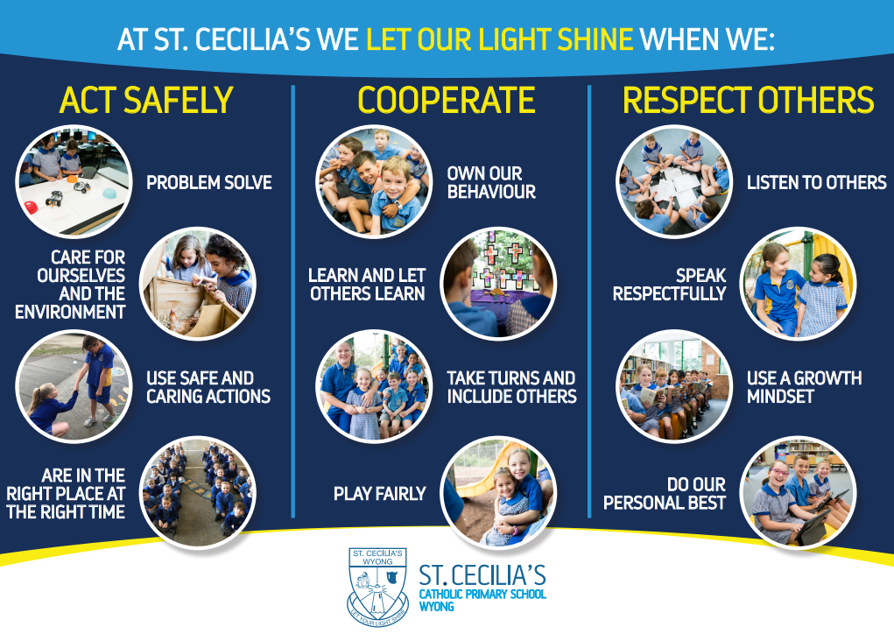
The discipline practices are respectful of the dignity, rights, and fundamental freedom of individual students, and at the same time are focused on the appropriate running of the school for the benefit of all.

Student Leadership Opportunities
K- 6 Mini Vinnies Leaders – Mini Vinnies is made up of a boy and girl from each class K-6, voted in by their peers. The group focuses on doing good works in the community that benefit people facing social injustice. It is also about young people meeting to talk, share ideas and concerns, to have fun and support each other. Mini Vinnies empowers our children to become advocates within their school and local community by putting their values into action. They meet regularly to talk, share ideas and concerns about social justice issues, develop leadership skills and engage with the wider St Vincent de Paul Society.
Student Representative Council (SRC) - The Student Representative Council (SRC) meets on a regular basis at lunchtime. The SRC consists of a representative from each primary class (Years 3-6) as well as the School Captains. The SRC discusses matters of interest to the student body and provides a student voice into the decision-making process at St Cecilia’s.
Peer Support Program - The highly regarded Peer Support program involves children in Years 5 and 6 working with a mixed group of students from other classes to promote a community aspect to the school or to discuss issues relating to “bullying” and other social issues as part of our Pastoral Care Program. It provides an opportunity of leadership for the senior students as well as support and links for the younger students. Training for the program will take place in Term 1 each year with Year 5 and 6 students at a dedicated leadership day supported by students from St Peter’s College, Tuggerah.
Year 6 Buddy and Kindy Buddy Program - To help the new kindergarten children settle into the school community – the school utilises a buddy system. Each Year 6 child is given a kinder child to look after and to be a special friend to for the first 12 months of school. They are there to help the kindy children on the playground or on their buses. It also enables the Year 6 children to develop a responsible attitude towards the newest members of our school.
Year 6 TEAM’s (Together Everyone Achieves More) – Each year six child nominates themself for a leadership role in one of the following TEAM’s:
Our Pastoral TEAM works closely with the Religious Education Co-ordinator to promote our faith and incorporate annual social justice awareness events or fundraisers throughout the year.
Our Environmental TEAM is made up of a collection of enthusiastic children from Year 6 who have a passion for the environment and its protection. They promote environmentally friendly practices among the school community and are responsible for ensuring that the environment at St Cecilia’s is looked after through the establishment of sustainability programs.
Our Wellbeing TEAM works with the Principal and Wellbeing for Learning Coordinator on planning and coordinating wellbeing improvements and suggested activities or events.
Our Arts Committee inspire creativity and are a support crew throughout the planning, rehearsal and preparation time of the musical. This group of children works closely with Mrs Whyte (Dance/Drama and Music teacher) sharing their creative talents in music, visual arts, dance or drama.
Our Student Digital Leaders Team work closely with the Digital Pedagogies Leader as the Program aims to extend learning outcomes for children by allowing them to develop and utilise their expertise in the usage and functionality of technology. These children are deemed to be technology experts; with the ability to problem solve, possess advanced technical skills and an awareness and appreciation for how using technology can enhance their own learning.
The goal of these TEAM’s is to involve our year six children in leadership roles in a purposeful and meaningful way where they extend and use their individual gifts and talents to inspire others.

Support for Students & Families
The School Counsellor is available to assist students and their families when the need arises. The school may initiate this support, or it may be a request of parents to gain access to the school counsellor.
A Family Liaison Officer (FLO) assists and promotes the relationship between the school and home. There are numerous initiatives planned for parents to assist them in their child’s schooling years.
The Family Liaison Officer (Natasha Harman) works in conjunction with the Principal and school teaching staff to assist in maintaining contact with families during difficult times and can provide support, resources and referral to outside agencies such as Catholic Care.
The FLO also plays an integral role in the various programs run by the school including the Transition to School Program for new kindergarten students and their families.
Additionally, the FLO facilitates parent education workshops, such as;
Circle of Security International Parenting Program - An 8 week evidence-based parenting program focusing on attachment and identifying your child’s needs. Designed to enhance the bond and sense of security for both the parent and the child.
Tuning In to Kids Parenting Program - A 6 week evidence-based parenting program that helps children learn to understand and regulate their emotions with the help of their parent/caregiver. Children with good emotional intelligence often have better emotional, social, and physical functioning, as well as fewer behavioural issues.
Triple P Parenting Program - A 7 week parenting program that gives parents simple and practical strategies to help them build strong, healthy relationships, confidently manage their children’s behaviour and prevent problems developing.
123 Magic & Emotion Coaching Parenting Program - A 4 week parenting program that is designed as a discipline program. It focuses on identify the behaviours we need to act on and implementing time-outs for inappropriate behaviours. It helps adults gain control of their emotions and eliminates lots of talking. It helps the child to recognize that certain behaviours result in specific and consistent consequences.
Tash is also trained to deliver domestic violence programs for women and men and has programs available that help to educate children on healthy relationships, their social and emotional wellbeing and social awareness.
Please call the office or email Tash Harman at natasha.harman@dbb.catholic.edu.au if you wish to meet or talk with the Family Liaison Officer.

An Aboriginal Education Worker (AEW) is Jodie Bourke. She assists Aboriginal and Torres Strait Islander Children in their education to enhance their physical, social, emotional and intellectual development. The AEW provides feedback to parents or guardians and teachers about students’ progress, and liaises with education bodies, government agencies and committees.

Our Learning Diversity Support Team is designed to identify those children who have specific needs and to plan and implement appropriate intervention as required. The program is coordinated and provided by a full time Learning Support Teacher and part time Learning Support Aides as well as Learning Support Aides for targeted funding applied for children as needs arise. The targeted funding applications are reviewed by Catholic Schools Broken Bay.
In general, the Learning Support Program is available to children who may have specific physical, intellectual, sensory, or emotional needs and/or children who may be gifted and talented.
Our model aims at supporting children to learn within the mainstream school. This is achieved by working with children in class or, in some cases, withdrawing children individually and in small groups where intervention may be required. Learning Support at St Cecilia’s utilises a team approach incorporating the many talents of children, parents, and teachers, as well as educational and medical professionals.

COMMUNICATION
At St Cecilia’s we are committed to a partnership with parents in the education of their children. There are many forms of communication, where parents can stay informed and connect with the school.

Appointments
Parents are encouraged to speak with the class teacher or Principal if they are concerned about their child or any matter related to the school. The class teacher should be the first point of contact for class matters, however, if appointments are necessary and parents are asked to contact the school via the school office scw@dbb.catholic.edu.au to arrange a suitable time.

Communication Channels

Compass - Updated regularly with calendar events, conferences (parent/teacher meetings), live stream/Zoom links and class/grade or whole school information and notices. Alerts and email notifications should always come through to all primary parents and carers.

Curriculum Overview - At the beginning of each term your child’s class teacher will provide a curriculum note communicating specific learning intentions for all subject areas. Important information such as class sport day, schedule of specialist classes will also be specified.

Email contact - All staff are accessible via the email by sending correspondence to the school email account mailto:scw@dbb.catholic.edu.au. Please clearly identify which teacher and class you wish the correspondence forwarded to. It is essential that parents understand that due to the nature of their work it may not be possible for the class teacher to respond within 24 hours. A response will generally be made within 72 hours. If the matter is urgent please call the school office.
Please do not email change of arrangements for child going home in the afternoon or any matter that requires immediate attention regarding your child. Please contact the school office directly before 2pm if you require a message to be given to your child regarding an afternoon change of arrangements.

Facebook Pages
- The Parent Hub Facebook page is often updated with school events, information, and questions.
- The St Cecilia’s Primary School Wyong Facebook page is often updated with gallery images of events that have occurred in the school. At times upcoming events are posted too.

Fortnightly Newsletter - Details about anything school-related. Awards, Teaching & Learning from the AP, REC news, FLO update, schedule changes, updates, events, policy reminders, news, articles, community happenings…anything important and enjoyable will be included here. Each fortnight on a Wednesday the newsletter will be made available to download on the school website and through the Compass App.

Principal’s Update - Every other Wednesday, upcoming ‘Dates for the Diary’ and a brief overview will be provided in the Principals’ Update. This will be sent out via Compass, also available to download from the school website under ‘News and Events.’

School Website - Stationery requirement lists, download versions of notes, Absence of Leave forms, enrolments, and the school newsletter. Maintained to ensure current information is available. Gallery of images from school events also updated frequently Permission Notes: Permission notes are sent home via Compass as an Opt-in event. If you are unable to access the permission form please email the front office who can supply you with a paper copy.

Parent Goal Setting Meetings - At the beginning of the school year and in term three parents are invited to attend a goal setting session for their child. Also, a Google Form will be sent home for parents to share some goal ideas and more personal information about their child before the meeting.

Parent Teacher Interviews - Parent teacher interviews are offered in both Semester 1 and Semester 2 after the reporting period.

School Reports - Student reports K-6 are distributed via the Compass Parent Portal in June/July and December. Parents will be notified via Compass when these reports are accessible.

Contact Details
As it is most important that the school be able to contact a parent at any time of the day, parents are asked to make sure that any change in address, mobile and home phone numbers is made known to the school. Please ensure we also have your most current Emergency contact details, should a parent/carer not be accessible when the school is trying to contact them.

SCHOOL ORGANISATION

Allergies
The College has a commitment to minimise the risks associated with severe anaphylaxis reactions to nuts. While it is impossible to create a risk-free environment, staff, students and parents can take important steps to minimise the potentially fatal allergic reactions. For some people, severe allergic reactions can be triggered not only by eating foods, but also by their touch and smell. As we have children with peanut allergies, peanut products are not sold at the canteen and we ask parents to support this by not sending products containing nuts to school with their children.

Asthma and Anaphylaxis
St Cecilia’s is committed to supporting students’ health and wellbeing and requests that you provide the College with any relevant health information essential to supporting your child. Whilst this information is collected at enrolment it is crucial that any change in this information is provided to the school immediately. Any student who suffers from anaphylaxis, severe asthma, diabetes, epilepsy, heart conditions or other significant medical conditions is asked to complete additional action plans/health care plans. If this applies to your child, please contact the College via …​ and an appropriate form will be emailed to you for completion. These plans must be completed in writing and signed by the parent/guardian and the medical practitioner/prescribing or qualified health professional.
If your child has a specific Asthma Management Plan, please ensure a copy is given to the school for our records. If your child requires a puffer, please ensure they have their puffer in their school bag.

Attendance and Absences
Please send your child to school on time each day. Regular attendance at school is essential for progress. Should your child be absent from school for any reason the school must be notified in one of the following ways:

- An online note via Compass
- a phone call to the school office
- an email sent to the office stating the cause of the absence for school records.
It is a legal requirement that class rolls are marked each day by the class teacher and all notes regarding a child’s absence are retained with the roll.
Any student absent from class in the morning will be marked as absent. A notification is sent to your Compass App for you to enter an explanation.

ABSENCE 10+ days
Permission from the principal must be sought after if your child will be absent from school for 10+ days, as well as entering the absence in the Compass App. A Form A1 Application for extended leave is required to be completed by parent/guardian and submitted to the school office.
Part 2, 4(b) of the NSW Education Act (1990) states that the education of a child is primarily the responsibility of the child’s parents. It should not therefore be an expectation of parent(s)/carer(s) that the school provide work for the student during the time of the extended leave.

LATE ARRIVAL
If your child is late to school, they should be accompanied by parent/carer to the school office and parent/carer will sign them in via the Compass Kiosk in the school office foyer. The Compass Kiosk Late Arrival slip is to be handed to the class teacher by the student. Your child will have been marked “absent” by the class teacher, however the sign-in via the Compass Kiosk will then override the absence.

EARLY DEPARTURE
If is it necessary for your child to leave early please visit the school office to sign your child out via the Compass Kiosk. The school office will contact your child’s class and arrange for your child to meet you in the school office foyer.

Excursions or Incursions
Class teachers plan excursions or incursions for all grades. These are always relevant to the delivery of curriculum. When children are to go on a school excursion or to a sports carnival, a permission note will be sent via Compass from the Events section. For convenience parents can complete permission notes online, via the Compass app.

Fees
Fees are paid directly to the school. BPAY is the school’s preferred payment option. Tuition Fees are determined by the Catholic Schools’ Office. The following sibling discounts are applied on the Education Fee:

1st child – $2880
2nd child - 25% for the second child
3rd child - 55% for the third child.
4th child – No tuition fees are charged for the fourth or subsequent children.

School fees are billed annually at the beginning of Term 1 by CSBB and are due in 10 monthly instalments. The first instalment is due February and the last payment being in November. School fees may be paid more frequently (annually, fortnightly or weekly), however the monthly instalment amount is to be paid by the 21st of the month. Our preferred method of payment for fees is BPAY. Fees can also be paid by EFTPOS or Credit Card.

Immunisation
Parents enrolling Kindergarten students need to present the school with an Immunisation Certificate. No child will be prevented from enrolling, however, under the Public Health (Amendment) Act 1992, children without a certificate may be sent home during an outbreak of a vaccine preventable disease.

Library
The library is open from Tuesday to Thursday each week for classes. Monday is a day for Administration time for the Librarian.
Classes visit the library for regular lessons, and classes/groups/individuals may use the library at lunch time and other times by arrangement. All children must have a Library Bag in order to borrow. The children borrow during their library period and may also borrow before school and during the lunch hour.
Books are normally borrowed for a period of two weeks, but books can be renewed if required. Any lost or damaged books must be paid for. Parents can assist with the functioning of the library by encouraging their children to borrow and take care of books.

Lost Property
Lost items of clothing are held for several weeks. If they are not claimed after this, they are either given away or sent to the Clothing Pool. Please enquire at the Office if your child is missing an article of clothing or check the lost property container outside the learning support office. Please ensure all items are labelled to enable these items to be returned to your child if found.

Local Excursions
To attend Masses and liturgies in the Church, the children are required to walk to our Parish Church nearby. To attend our Cross Country, the children walk to Wyong Racecourse and for some sporting activities, Baker Park, which is also nearby. On other occasions, teachers may plan short walking excursions around the community eg. to the railway or shopping centre. You will be asked to complete a general permission note for these local excursions if you give your child permission to do so.

Medical Matters
Administering Medication
Staff at St Cecilia’s will only be able to administer medications to students when accompanied by written instructions from a medical practitioner. This includes all prescribed medications such as for diabetes or ADHD, and all non-prescribed medications such as Panadol and Nurofen.
Emergency
All staff are prepared for first aid Anaphylaxis, Asthma and CPR training. This training is refreshed annually. All administrative staff and other teachers dispersed across the stages are full first aid trained too. Should an emergency arise with your child/children, all efforts will be made to contact the parents, carer or emergency contact listed; and emergency measures will be undertaken by the Principal or Assistant Principal.
Any serious accident or injury is immediately treated, and parents/carers are contacted. It is the parent or carer’s responsibility to notify the school of changes to contact phone numbers for home, work, and emergency contacts.
Is it IMPORTANT that the emergency contact be someone OTHER than the parent eg a grandparent, neighbour or close friend of the family. Parents will always be the first point of contact should an emergency arise, however, if we are unable to contact parents, we will then use the nominated emergency contact provided.
Sickness
A child who is not healthy cannot concentrate on schoolwork. If your child is unwell, please keep them at home until completely well.
If a child is sick at school, the teacher will contact the School Office to advise that the child is being brought to Sick Bay. If your child needs to be sent home, the school office will then contact a parent and make the necessary arrangements.

Mobile Phone and Wearable Devices
Messages for children can be phoned into the school office. There is no need for a mobile phone at school. If a parent requires their child to have a mobile phone for AFTER school contact, it is to be kept in the child’s bag and turned off and is not to be used in school time.
Wearable devices should be treated the same as mobile phones at school, so not to be used for calls or texts during school hours.

Payments
Any donations or other monetary payments for events are often requested through Qkr. If unable to pay online through the Qkr app please pay to the school office with money in an envelope clearly labelled with the child's name, class, amount enclosed and what the money is for. Such payments are preferably collected at the beginning of the school day in classrooms and taken to the office for sorting, however cashless payments are preferable.

Photo/Video Permission
We value student privacy. Each year parents will be asked to complete a photograph/video permission form via Compass. This helps the school ensure we only utilise images of children whose parents have given consent for them to be photographed and utilised in newsletters, Facebook or other marketing materials.

Policies
Catholic School Broken Bay develops, publishes and assists schools to implement a range of policies setting out clearly the approaches we take to important issues. The policies explain who is responsible for putting in place processes within each policy. By adopting system wide approaches, we ensure consistency of decision making between schools and within a school. Policies also provide a statement of intent from which school procedures and guidelines can be developed. The policies are located on the Catholic Schools Broken Bay website. Catholic Schools Broken Bay - Policies

Raising Concerns
St Cecilia’s fosters a harmonious, positive and safe school and community for all students, parents and staff. The school relies on clear and open communication with the community and aims to resolve complaints or concerns fairly, efficiently, promptly and in the best interests of all. Confidentiality and privacy are always respected in processes taken to resolve any matter. A Guide to Making a Complaint brochure is available at the school office and the Complaints Handling Policy can be located on the Catholic Schools Broken Bay website.

School Photos
School Photos are taken each year on an alternating basis of seasons. Children are photographed in their summer uniform one year and their winter uniform the next.

Sport
Sports activities are held 1-2 times a week for each grade. Your class teacher will notify you of which day at the beginning of the year. School Athletic, Swimming and Cross Country Carnivals are held each year and the school takes part in the Combined Catholic Schools Swimming and Athletics Carnivals. Representatives are chosen from these Carnivals to represent the Central Coast at Diocesan level carnivals.
Years 3 - 6 will participate in the Surf Awareness Program.

Sport Colour Houses
In Kindergarten students are allocated to one of four colour houses Blue (Joseph), Green (Woodbury), Red (Raymond) or Yellow (Mackillop). Siblings of older children are placed in the same colour house as their family members. Children without older siblings are then allocated to colour houses to balance numbers.

Staff Development Days
Staff Development days are conducted each year. These days are designated for staff to work together on planning or developing an aspect of the school. These are declared pupil-free days and notice of such will be given well in advance. The first day of the year and final day of the year are often designated staff development days with an extra 2-3 others throughout the year.

Supervision
Morning supervision commences at 8:15am. It is important that children are not in the school grounds before supervision commences. Bus companies are aware of this commencement time and should not be dropping children at school before supervision begins.
After-school supervision ceases when the last bus leaves the school, at approximately 3:30pm. In the event of a problem when children are not collected in the afternoon, they will be supervised in the front office and parents will be contacted.
An Out of School Hours Care (OSHC) Program is available on the school grounds. If you are interested in this service, please contact the office for information.

Travel
BUS LINES AND THEIR DESTINATIONS
BUSWAYS CENTRAL COAST:
Phone 4392 6666 Wyong, Wyongah, Kanwal, Gorokan, Toukley, Warnervale, Charmhaven
ENTRANCE RED BUS:
Phone 4332 8655 The Entrance, Berkeley Vale, Chittaway.
COASTAL LINER COACHES:
Phone 4392 3050 Dooralong Road, Dickson Road, Wyee Station / Via Hue Hue Road

STUDENT OPAL CARDS
Application for subsidised student travel needs to be completed online at transportnsw.info/school-students. To report a lost or stolen opal card, parents need to phone 131500 or visit transportnsw.info/school-students.
Children in the infants’ classes are entitled to free bus travel irrespective of where they live but need to still apply online.
Primary children must live 2.3 km from the school before they are eligible for a free bus pass.

TRAVEL TO AND FROM SCHOOL
Conduct of children on buses to and from school is the combined responsibility of the parents, the bus company, and the school. There is a limit to what any one of these three can do independently. Please assist the school by ensuring that children know the rules of public transport, i.e. remain seated if possible; never throw anything from a window; be courteous; never distract the driver while the bus is in progress etc.
PRIVATE VEHICLE CONVEYANCE SUBSIDY
To be eligible for Private Vehicle Conveyance Subsidy there must be no alternative bus or train transport available and students must reside more than 1.6 kilometres (walking distance) from the nearest transport pick-up point.
CHILDREN WALKING/RIDING OR BEING COLLECTED
Children walking home, or riding a bicycle, who need to cross Panonia Road are to cross at the Supervised Crossing. Parents are requested to collect their children from under the school hall. Parents are requested to park outside the school grounds, not in the staff car park as this causes safety problems. Children’s safety is paramount. Children walking or riding home will be escorted to the gate by a teacher and across the Pedestrian Crossing, if required.
PARKING
Because of the associated dangers to your child, it is hoped that all parents who are dropping and collecting children each day are asked to observe the following rules:
- No car is to enter the school grounds or driveway.
- No parking or stopping in the designated bus zones.
- Please escort your child across the road if they need to cross, as it is a busy street.
- Please keep our neighbours’ driveways clear.
- Lead by example and show your children the safe way of negotiating a busy road.
SCHOOL CROSSING
A Crossing Supervisor, employed by Service NSW, supervises the School Crossing. They are at the crossing each morning and afternoon.

Uniform
Students are expected to always wear the full correct uniform. Uniform items can be purchased from "Lowes" at Westfield, Tuggerah. A small selection of second-hand uniforms are also available from the school clothing pool.
 | SUMMER UNIFORM | WINTER UNIFORM
GIRLS | Blue, white and gold check uniform | Blue check tunic OR navy-blue slacks
 |  | White long-sleeved Peter Pan collared shirt
 | Short white socks – above the ankle | Navy tights OR white socks
 | (Year 6 only) Royal blue check skirt and short sleeve white Peter Pan collared shirt | (Year 6 only) Royal blue check skirt with long or short-sleeved Peter Pan collared shirt
BOYS | Grey school shorts (no cord or board shorts) | Long grey school pants (classics style) OR Grey school shorts with long socks (see below)
 | Blue short sleeved shirt with lay-back collar | Blue long or short sleeved shirt with lay-back collar
 | Long OR short grey socks with a blue/gold  band | Grey school socks with trousers OR  Long grey school socks with blue and gold bands with shorts
 |  | Royal blue sloppy joe or zip jacket with school emblem.

SCHOOL HAT & BAGS - School hats are compulsory all year round. The school hat and school bag are compulsory uniform items. They can be bought from the school office.
Hats = $20 School bags = $45 Library Bag (optional) = $20

SHOES
- Black leather school shoes - (all black, no coloured soles or trim, no platform heels. Buckles or laces are acceptable)
- Appropriate running shoes (preferably plain colours)
 | SPORT SUMMER UNIFORM | UNISEX SPORT WINTER UNIFORM
GIRLS | Royal blue pleated sports skirt or Royal blue shorts | Royal blue tracksuit with school emblem (in winter)  Blue and Gold polo shirt (with school emblem)  *Year 6 students may wear their Year 6 shirt
 | Blue and Gold polo shirt (with school emblem)
 | Short white socks
BOYS | Royal blue Ruggers shorts (not soccer shorts)
 | Blue and Gold polo shirt (with school emblem)
 | Short white socks

NOTE:
* ZIP JACKET OR SLOPPY JOE MAY BE WORN ON ANY DAY THAT IT IS NEEDED.
* TRACKSUIT PANTS ARE ONLY TO BE WORN ON SPORTS DAY

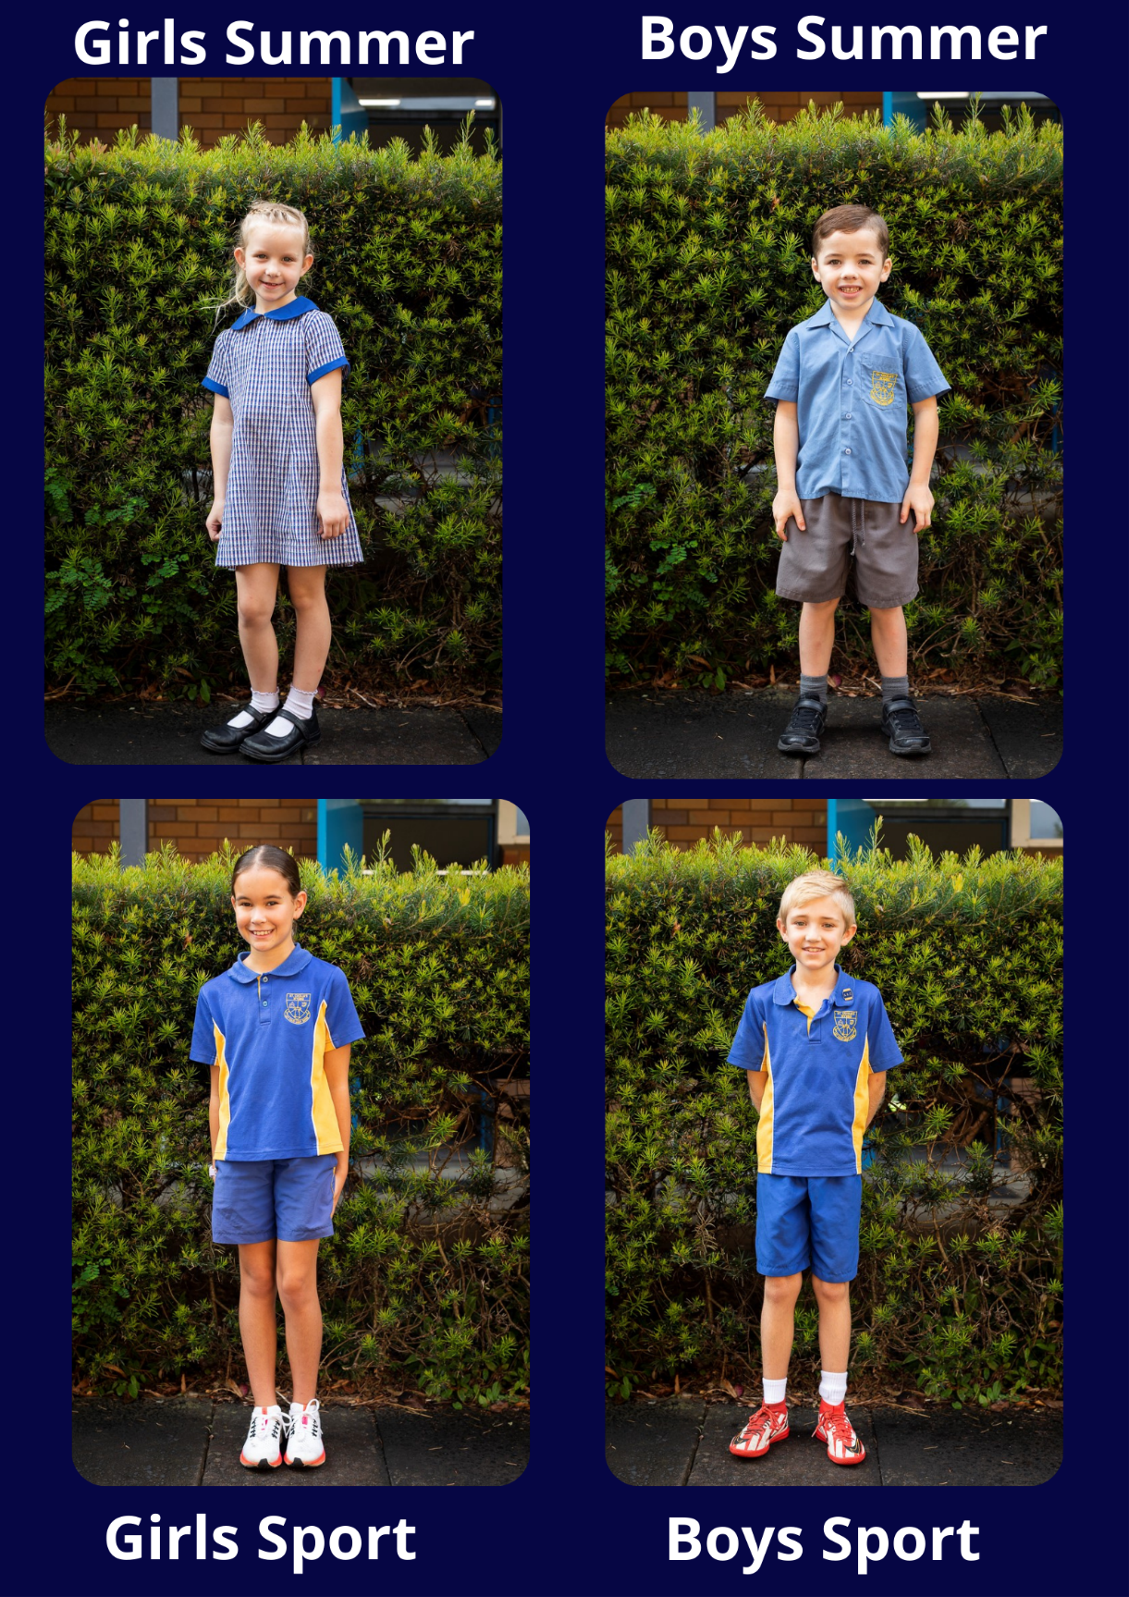

MARKING CHILDREN’S BELONGINGS
All items should be clearly marked with your child's name. This is essential for all items of clothing and belongings. Parents should encourage their children to look for lost property.

JEWELLERY
No ornate jewellery is to be worn to school. Children are permitted to wear a watch and one pair of studs or sleepers in their ears. Sacramental chains ONLY may be worn if they are kept under the tunic or shirt.

HAIR
Hair should be always kept clean and tidy. Long hair on both boys or girls should be worn tied back. Hair dyes and ornate hairstyles eg mohawks etc are NOT allowed at school.

Valuables
Students are not permitted to bring valuable toys or electronic equipment of any kind to school. If they do so, then the school accepts no responsibility for loss or damage

Visitors
All visitors to St Cecilia’s must sign in at the Compass kiosk at the school office and take a visitors’ badge to wear. Staff members are identifiable by their name badges.

PARENT PARTICIPATION
The parents of St. Cecilia's play a vital role in the school's long-term planning and in its day-to-day routines and organisation. Parents and teachers at St. Cecilia's work in close partnership and, in addition to meeting with teachers at official Parent-Teacher meetings, parents are always welcome to make an appointment to see a teacher outside of teaching hours.

Families Leading in Partnership (FLIP)
Our FLIP meetings occur throughout the year in the morning or evenings. The meetings are an opportunity to build community through social interaction and to be active in the key purpose of the school. The structure of the FLIP group
TEAM  (fluidity) | STAFF LEADER | GUIDING PRINCIPLES | RESPONSIBILITIES
Community Building | Principal | - Building a welcoming and inclusive community for existing and prospective families.  - Respond pastorally to the changing needs of our community.  - Support a welcoming school culture encouraging the engagement of all families | - Organise welcoming events and activities, per grade and whole school  - Inclusive events responding to St Cecilia community needs  - Pastoral care for families  - Optional fundraising to provide resources for enriching learning environments.  - Fundraising to be aligned to school improvement goals and spent in a school year  - Implement “just one thing” so all families can contribute to the school
Parent/Carer  Connectors | FLO | - Creating circumstances for open, respectful, and responsive communication channels.  - Connecting and encouraging parent voice in the community.  - Provide balanced parental voice to assist school principal and parent team.​ | - Class parents attend all FLIP meetings.  - CSP parent representative: Keeping community up to date with and communicate current developments in Catholic Education at Diocesan (CSBB) and (CSP) and State level (CCSP).​  - Feeding back parent voice to Principal  - FLIP communication/social media /Facebook group coordination  - Family feedback surveys  - parent survey/communication to set agenda/discussion at parent open forums  - FLIP communication through COMPASS
Faith and Learning Partners | AP &  REC | - Building parent capacity to engage and be partners in their child’s learning and wellbeing.  - Parents are engaged and valued in their child’s education.  - Co- responsibility of the school and families in student achievement and wellbeing.  - Connecting families to parish and spiritual formation.  - Develop authentic learning partnerships and create a community of learners. | - Organise parent education forums and resources  - Develop a parent engagement plan  - Parent engagement projects e.g sustainability  - FLIP Forum - Pastoral Discernment Project  - Seek community feedback re agenda for FLIP Forum  - Parent spirituality events  - School/parish links and events
Advisory Team | *Principal  *LeadershipTeam  *CSP Rep.  *Parent rep. from;  - Community building TEAM  - Parent Connectors TEAM  -Faith & Learning Partners | - Bring school leadership, school staff, families, parish, and community representatives together as partners to support student learning, wellbeing and faith development  - Guided by school improvement plan and CSBB Towards 2025 Projects | - Collaborate and share responsibility for school improvement plans and procedures through advice, problem solving and evaluation  - School leadership ,school staff and families work together on learning initiatives and projects  - Work with class connectors/feedback channels to support decision making and advise  - Support FLIP in implementation of responsibilities

Parent Helpers/Volunteers
The participation, involvement and help of parents, close relative and other volunteers are welcome and appreciated for various activities both in school and on excursions.
It is important that all volunteers are aware that they are subject to child protection legislation. This means all volunteers must:
- Sign on at the front office via the Compass Kiosk.
- Check with the school what the current requirements are for Working with Children and ensure to comply with the requirements before attending any excursion or in-class activity. (see Appendix A – Working With Children Check).
- Are technically not employed by the school, they are considered to be ‘staff’ for legal purposes and need to be aware that complaints about inappropriate behaviour towards any child or young person must be investigated (see Appendix B & C).
There are many ways in which parents can become involved in the school, e.g.:
Attendances at Events - Attendance at Parent/Teacher Meetings, Information Nights, School Concerts, Sports Carnivals, and the School's Annual Presentation Night is encouraged both for your child and school's benefit. Such activities provide parents with opportunities to meet staff and other parents and give them a sense of belonging in the school community.
Canteen - Parent volunteers are always welcome in the canteen. A minimum of 2-3 volunteers are required each canteen day. Please e-mail the office if you can assist in any capacity.
Classrooms - Some teachers, particularly those who teach the younger children, will send home a note within the first weeks of the school year, requesting assistance in such areas as reading, writing, mathematics, craft, computers or as a guest speaker. The tasks are clearly outlined by the class teacher. Helping in the classroom is a great way of meeting the children in your child's class.
Class Parents - Kindergarten has a Class Parent allocated to it at the beginning of the year. The Class Parent supports the class teacher and provides a link between the school and parents. The classroom facilitation a class parent provides can take many different forms and can require anything from a minor volunteer commitment shared with other parents to a large responsibility. The class parent liaises regularly with the Family Liaison Officer.
Excursions - Excursions are designed to supplement and enrich the children's classroom experiences and they often require parents to volunteer as supervisors to ensure have our adult to child ratio right.
Masses, Liturgies and Assemblies - The children have regular opportunities to participate in the celebration of Masses, liturgies, or assemblies. Parents are always welcome and encouraged to join us on these occasions. Our main assembly mornings are Monday and Thursday and every second Friday we host our Awards Assembly at 2:30pm. All parents are always welcome to our assemblies.
Parent Room - The Family Liaison Officer runs a Parent Room where parents can come and meet over coffee, look at resources and spend time getting to know other parents. The Parent Room is open on Tuesday and Thursday mornings.
Social Events - The assistance in coordination and organisation of social events, which the FLIP Community Building Team will initiate throughout the year.
Sport and Physical Education - St. Cecilia's offers its students many opportunities to participate in sport, e.g. swimming, athletics and cross country carnivals at school, regional and diocesan levels; soccer, netball and rugby league gala days; as well as weekly sport for all students. In addition, the infants’ grades participate in a gross motor skills program. Parental help ensures that these carnivals and gala days run efficiently.
Surveys and Questionnaires - These are sent out when needed, to gain input from parents about school matters e.g. Discipline, Uniform, Homework etc. Parents are invited and encouraged to respond to them as their ideas, suggestions and recommendations have considerable bearing on the direction the school takes.

APPENDIX

Appendix A – Working With Children Check
Working With Children Checks are required by staff, and certain volunteers and contractors in our
school.
The purpose of the check is to exclude people from working with children and young people who are not suitable. A person who has been convicted or found guilty of a listed serious offence against children (whether in NSW or elsewhere) is prohibited from child-related employment.
Parent participation, involvement and help are welcome and appreciated for various activities both in school and on excursions. It is important to note that all parent helpers / volunteers are subject to child protection legislation.
CSBB Safeguarding Office supports our school to fulfil obligations under Child Protection (Working With Children) Act 2012. Further information on the Working With Children Check can be found on the website for the Office of the Children’s Guardian. Further information can be found in the SAFEGUARDING & CHILD PROTECTION POLICY FOR CATHOLIC SCHOOLS BROKEN BAY: WORKING WITH CHILDREN CHECK (January 2021).

Appendix B - Safeguarding
We are committed to providing safe communities for students at our school to grow and learn as outlined in our Diocesan Commitment to Safeguarding. We recognise the rights of children as outlined in the Diocesan Framework on the Rights of the Child and promote safe and supportive environments where we all have a responsibility to keep children safe from harm.
All staff are expected to promote child safety and have a clear understanding of their legal child protection responsibilities and act in accordance with those responsibilities.
The NSW Child Safe Standards (NSWCSS) National Catholic Safeguarding Standards (NCSS) provide a principle-based framework that our school commits to using for continuous improvement as part of our commitment to safeguarding.

Responding to Risk of Significant Harm
All school staff are Mandatory Reporters. This means that if there are reasonable grounds to suspect that a child or young person is at risk of significant harm of abuse or neglect, then a report must be made to the Department of Communities and Justice (DCJ), Child Protection Helpline (CP Helpline) on 132 111. School staff and Principals are supported by CSBB Safeguarding Office as required and all records are stored confidentially.
We recognise that a statutory response is not always required and where a family may need extra support, we will assist in making referrals to support the family if needed.
If you have concerns about a child or young person who you consider may be at risk, we encourage you to discuss your concerns with the Principal as soon as possible and maintain confidentiality.

Appendix 3 – Maintaining Professionalism
All staff, volunteers and contractors are expected to act professionally and in accordance with the school’s expectations regarding staff conduct toward children and young people. Guidance and professional development about appropriate interactions with students, how to exercise duty of care and how to maintain professional boundaries is provided.
We understand that staff, volunteers and contractors have a duty of care to:
- Ensure no child or young person is exposed to foreseeable risk of harm;
- Take action to minimise risk;
- Supervise actively, and report concerns to the Principal or seek further advice if they see others acting inappropriately with children or young people.

Staff, volunteers and contractors strive to:
- Demonstrate appropriate relationships with children and young people that cannot be misinterpreted as overly personal or intimate;
- Remain within the responsibilities of their roles and allow those appropriately trained to deal with student welfare concerns;
- Minimise physical contact with children and young people unless it is necessary to exercise appropriate duty of care;
- Follow the school’s policies and procedures relating to pastoral care and wellbeing including serious incidents and reporting risk of harm.

Addressing complaints of inappropriate behaviour of adults towards children and young people
We are committed to providing a safe and supportive environment for both students and staff. This includes addressing complaints of inappropriate behaviour of staff, volunteers and contractors towards any child or young person.
Such complaints are handled differently to other types of complaints which may arise in the school because of legal obligations established by the NSW Children’s Guardian Act 2019. The NSW Office of the Children’s Guardian is a government agency which requires schools and other organisations working with children and young people to ensure systems are in place for recording and responding to all allegations of a child protection nature against staff, volunteers and contractors.
If you have concerns about alleged inappropriate behaviour by staff, volunteers or contractors towards any child or young person it is important that you discuss your concerns with the Principal who in turn will consult with the CSBB’S Safeguarding Office.
All complaints are taken seriously and follow a fair and confidential process which involves listening to all parties and giving opportunity for response. If the concerns involve alleged criminal behaviour they will be reported to the police and CSBB will wait for the outcome of the police investigation before continuing its own investigation. More information can be found in SAFEGUARDING & CHILD PROTECTION POLICY FOR CATHOLIC SCHOOLS BROKEN BAY: ADDRESSING ALLEGATIONS OF INAPPROPRIATE BEHAVIOUR BY EMPLOYEES TOWARDS CHILDREN (January 2021).

