KINDERGARTEN CLASS REQUIREMENTS – 2024

These items will be stored and shared among the class throughout the year (no names required as all items will be shared)  8 black whiteboard markers (Artline or Staedtler brand)  8 glue sticks (UHU or Bostik brand recommended)  Pack of 6 highlighters  2 large tissue boxes  3 large packets of wet wipes | For your individual child  Please ensure all items are clearly labelled with your name  - Twistable crayons (Crayola)  - Textas (Faber Castell set of 10-12 no Sharpies)  - 1 pair scissors  - Small Pencil Case: no pencil tins or equipment for their desk  - 1 plastic document wallets  - 1 library bag  - On-Ear Wired Headphones - Black - Kmart  - 1 A3 Display book J.Burrows A3 20 Pocket Display Book Black | Officeworks  - 1 student diary (see picture below-no larger than A5)  - Paint Shirt  - Spare underwear and socks (to be kept in bag)  - Lunch box and water bottle (easily opened by your child and labelled)  Please purchase enough clear contact to cover 4 books that will be sent home in 2024.

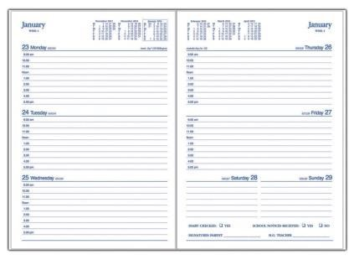

The kindergarten teachers look forward to welcoming you to our St Cecilia’s community in 2024.

