YEAR 1 CLASS REQUIREMENTS – 2024

These items will be stored and shared among the class throughout the year (no names required as all items will be shared)  8 black whiteboard markers (Artline or Staedtler brand)  8 glue sticks (UHU or Bostik brand recommended)  12 lead pencils HB (thick triangular grip/Officeworks supplies these)  2 large tissue boxes 3 large packet of wet wipes | For your Individual child  Please ensure all items are clearly labelled with your name  - Twistable crayons (Crayola)  - Textas (Faber Castell set of 10-12 no Sharpies)  - 1 packet of coloured highlighters (set of 4)  - 1 pair scissors  - Small Pencil Case: no pencil tins or equipment for their desk  - 2 x Plastic document wallets  - 1 library bag  - On-Ear Wired Headphones - Black - Kmart (photo below)  - 1 A3 Display book J.Burrows A3 20 Pocket Display Book Black | Officeworks  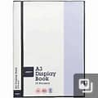  - 1 student diary (see picture below-no larger than A5)  - Paint Shirt  Please purchase enough clear contact to cover 6 books that will be sent home in 2024.

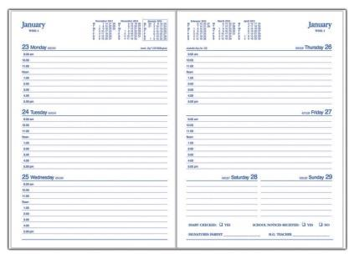

The year 1 teachers look forward to seeing you in 2024.

