For your individual child  Please ensure these items are clearly labelled with your name | For the classroom  These items will be stored and shared among the class throughout the year. Please discuss with your child that these items will be collected for communal use. These items do not need to be labelled with a name.
- 1 library bag  - 1 painting shirt  - 6 led pencils HB  - 1 pencil sharpener  - 3 erasers  - 4 pack highlighters  - 1 red pen and 2 blue pens  - 2 Artline 0.6mm felt tip black pens  - 1 pair scissors  - 30cm ruler  - Coloured pencils and textas in a small pencil case.  - 6 whiteboard markers  - 1 whiteboard eraser  - 2 packets of post it notes 76 x 76 mm  - 1 basic calculator  - 2 A4 plastic document wallets  - On-Ear Wired Headphones - Black - Kmart  - A3 Display book J.Burrows A3 20 Pocket Display Book Black | Officeworks 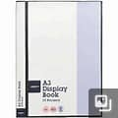 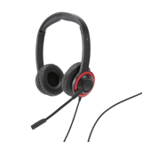 | - 12 glue sticks  - 2 packets of wet wipes  - 2 boxes of tissues  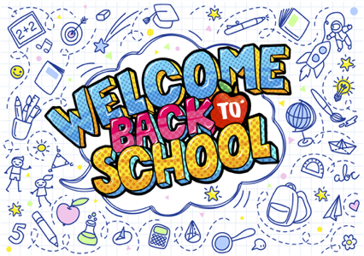
The year 4 teachers look forward to seeing you in 2024.
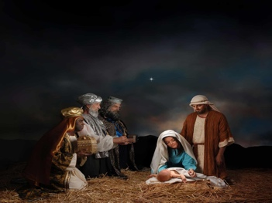
Have a restful, safe and wonderful Christmas.

