2024 - Year 2 Stationery Requirements
Please ensure all items are labelled clearly.

- Library Bag
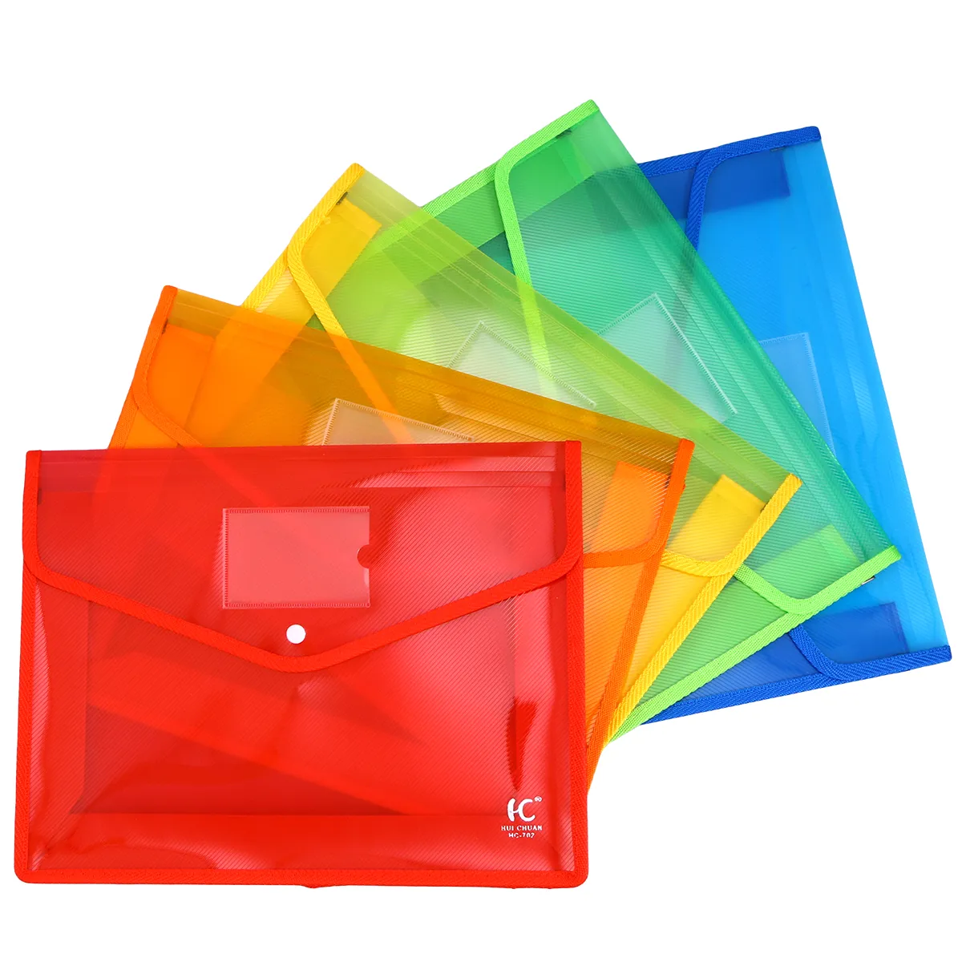
- Paint Shirt
- Lead pencils (at least 10)
- Homework folders x 3
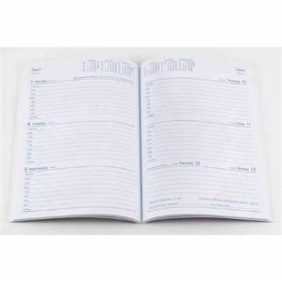
- Red pen
- Coloured pencils or crayons
- Student diary
- Textas
- Highlighters
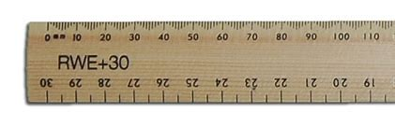
- Erasers (at least 2)
- Ruler (with cm and mm)
- Scissors
- Glue (at least 4)
- 2 x Artline 0.6mm felt tip black pens
- Whiteboard markers (at least 4)
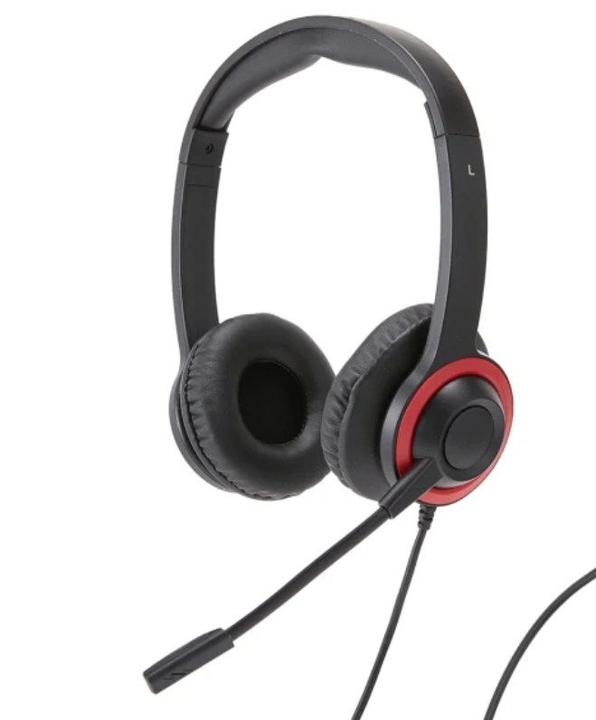
- Whiteboard eraser
- Pencil sharpener
- Headphones with microphone
- Wipes
- Tissues
- Paper towel OR a packet of zip lock bags
- A3 art folder
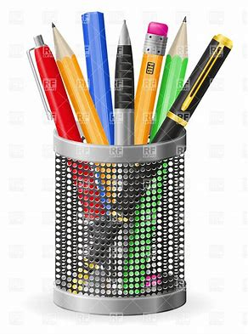
- Pencil case - please no large pencil cases
- Optional - Additional pencil tin or small pencil case to keep on desk - the bigger pencil cases are too big to keep on desks and will be kept in their tubs)

